Specialty Seasonings

Jalapeno Peppers Cheddar Cheese Pepperjack Cheese Swiss Cheese Mushrooms Chipotle Peppers Cranberry
Cherry Cajun XXX Hot Teriyaki Italian
Tomato Basil Buffalo Wing

Business Statement
We are committed to providing you with the best quality game processing possible. We
keep each customer’s game separate throughout the entirety of processing. This means what you bring in is what you get back!
Due to limited freezer space this time of year, we ask that you pick up your fresh
cuts/sausage within 4 days of notification of completion (voicemails/text messages included). A freezer charge of $1.00 per day, per box, will be added on the 5th day.
Please note If we cannot get a hold of you (wrong number, voicemailbox full/not set up, no longer in service, etc.) charges will automatically begin on the 5th day.
Product will be held for 6 months before disposing of.
2024 Gun Deer Extended Hours


Meat Market & Catering
2024

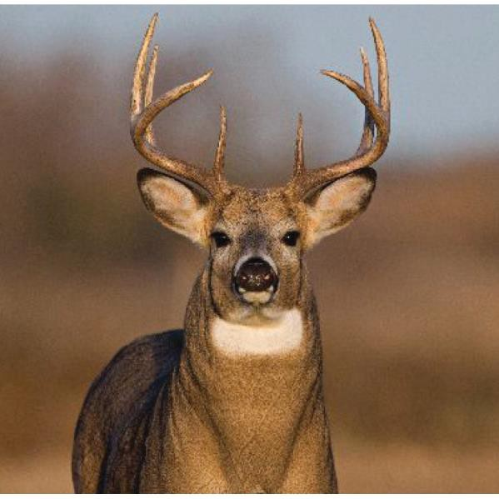
WILD GAME PROCESSING

Jamaican Jerk Gyro
Brats Only
Each Additional Ingredient: $0.50 No Limits!
Ask us for our favorite combos!

All Wild Game products are vacuum
Saturday, November 23rd
Sunday, November 24th Monday, November 25th Tuesday, November 26th Wed., November 27th Thursday, November 28th Friday, November 29th Saturday, November 30th Sunday, December 1st Monday, December 2nd
8:00 am - 3:00 pm
12:00 pm - 6:00 pm
6:00 am - 6:00 pm
6:00 am - 6:00 pm
6:00 am - 6:00 pm Closed Thanksgiving 6:00 am - 6:00 pm
6:00 am - 4:00 pm
12:00 pm - 4:00 pm
6:00 am - 6:00 pm

Stoddards Meat Market & Catering
205 East Cottage Grove Road Cottage Grove, WI 53527 608-839-4228

packed (except burger). Beginning Tuesday, December 3rd we will
be returning to our regular hours. www.stoddardsmarket.com

Processing Information
We will keep all Wild Game separate, this includes fresh cuts as well as sausage and smoked products. You will get your own meat back.

All Wild Game (except burger), fresh & smoked, are vacuum packed with a full ingredient list on the label.

All Wild Game is hand cut resulting in only boneless cuts to our customer.

We can process your Deer, Elk, Bear Antelope, Moose, or Bison.

We take in whole animals as well as quartered animals or trim.

Sausage Information
All sausage products are made with your Wild Game. To do this requires extra time and labor, but we think it's worth it to you, Our Customer. If you have any questions regarding this policy, please ask.

If you would like to have beef added to your sausage products rather than pork, please request it at the time that you place your order. We will be happy to honor your request.

$15.00 will be added to any sausage orders that are split between two products. Example: a 25 lb. batch split into 1 /2 summer sausage & 1 /2 snack sticks.

** Not all products can be split.

Whole Wild Game Processing

Basic Fee | $180.00
Hide Return fee: Cut Antlers/Head: | $ 15.00  $ 5.00
Cape your Trophy: | $ 65.00

Processing Includes:
Skinning, Cutting Fresh Meat, Wrapping & Grinding Trim for Burger.

Trim Ground into Burger
Grind & wrap $1.50/lb

Grind only $1.00/lb

We can add beef, beef fat or pork to any order for an additional charge.

*Boning charge: $40.00/qtr

Order Weight Minimums
All products require a minimum weight.

Summer Sausage & Snack Sticks
17/lb = 25/lb

Bacon, Brats, & Breakfast Sausage
10/lb = 20/lb

Ring Bologna & Wieners 15/lb = 25/lb

Whole Muscle Jerky Whole Hind Quarter.
Dried Venison Whole Hind Quarter

Trim to Sausage Products

Summer Sausage
Traditional, Garlic or Onion: $6.00/lb
For additional seasoning options see Specialty Seasoning List.

Ring Bologna $5.00/lb

Bratwurst
Classic Fresh, Garlic,
Onion or Beer added: $5.00/lb
Smoked: $5.50/lb

Wieners, Chorizo, Andouille
Traditional: $5.50/lb
For additional seasoning options see Specialty Seasoning List.

Snack Sticks
Regular, Garlic or Hot: $7.00/lb
For additional seasoning options see Specialty Seasoning List

Whole Muscle Jerky
(Requires whole hind qtr.) $12/lb.

Dried Venison
Whole Round, Smoked & Thin Sliced: (Requires whole hind qtr.) $8.00/lb.

Breakfast Sausage
Bulk: $4.00/lb
Links: $6.50/lb
Patties: $5.00/lb

Bacon: $6.00/lb

Add Pork $3.99/lb
Add Beef $4.99/lb

